1.Created bucket and provided replication rules and also destination bucket on the same Region

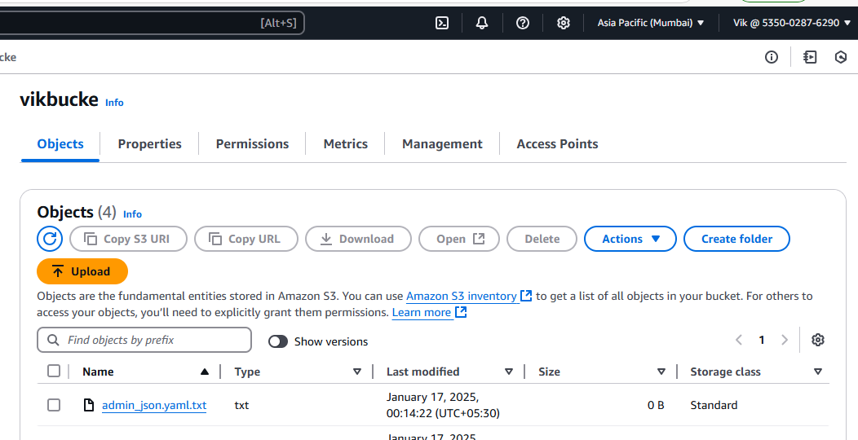

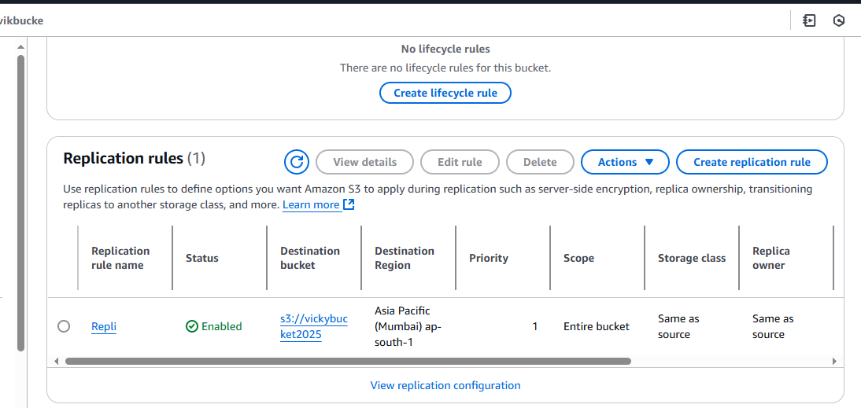

2. We can see object that was uploaded is replicated on the destination bucket

